16-QAM with MATLAB

# 重点函数介绍

## de2bi： decimal to binary

Convert the **Integer-Valued** Signal to a **Binary** Signal

## bi2de：binary to decimal

Convert the Binary Signal to an Integer-Valued Signal

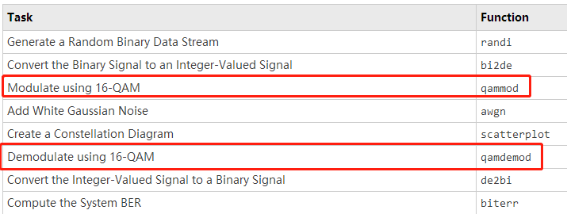

## randi：

Uniformly distributed pseudorandom integers，均匀分布的伪随机噪声。

**X = randi(imax)** returns a pseudorandom scalar integer between 1 and imax.

**X = randi(imax,n)** returns an n-by-n matrix of pseudorandom integers drawn from the discrete uniform distribution on the interval [1,imax].

**X = randi(imax,sz1,...,szN)** returns an sz1-by-...-by-szN array where sz1,...,szN indicates the size of each dimension. For example, randi(10,3,4) returns a 3-by-4 array of pseudorandom integers between 1 and 10.

**X = randi(imax,sz)** returns an array where size vector sz defines size(X). For example, randi(10,[3,4]) returns a 3-by-4 array of pseudorandom integers between 1 and 10.

X = randi([imin,imax],___) returns an array containing integers drawn from the discrete uniform distribution on the interval [imin,imax], using any of the above syntaxes.